Execute Ansible Ad Hoc Commands Using Password Authentication

Instances created:
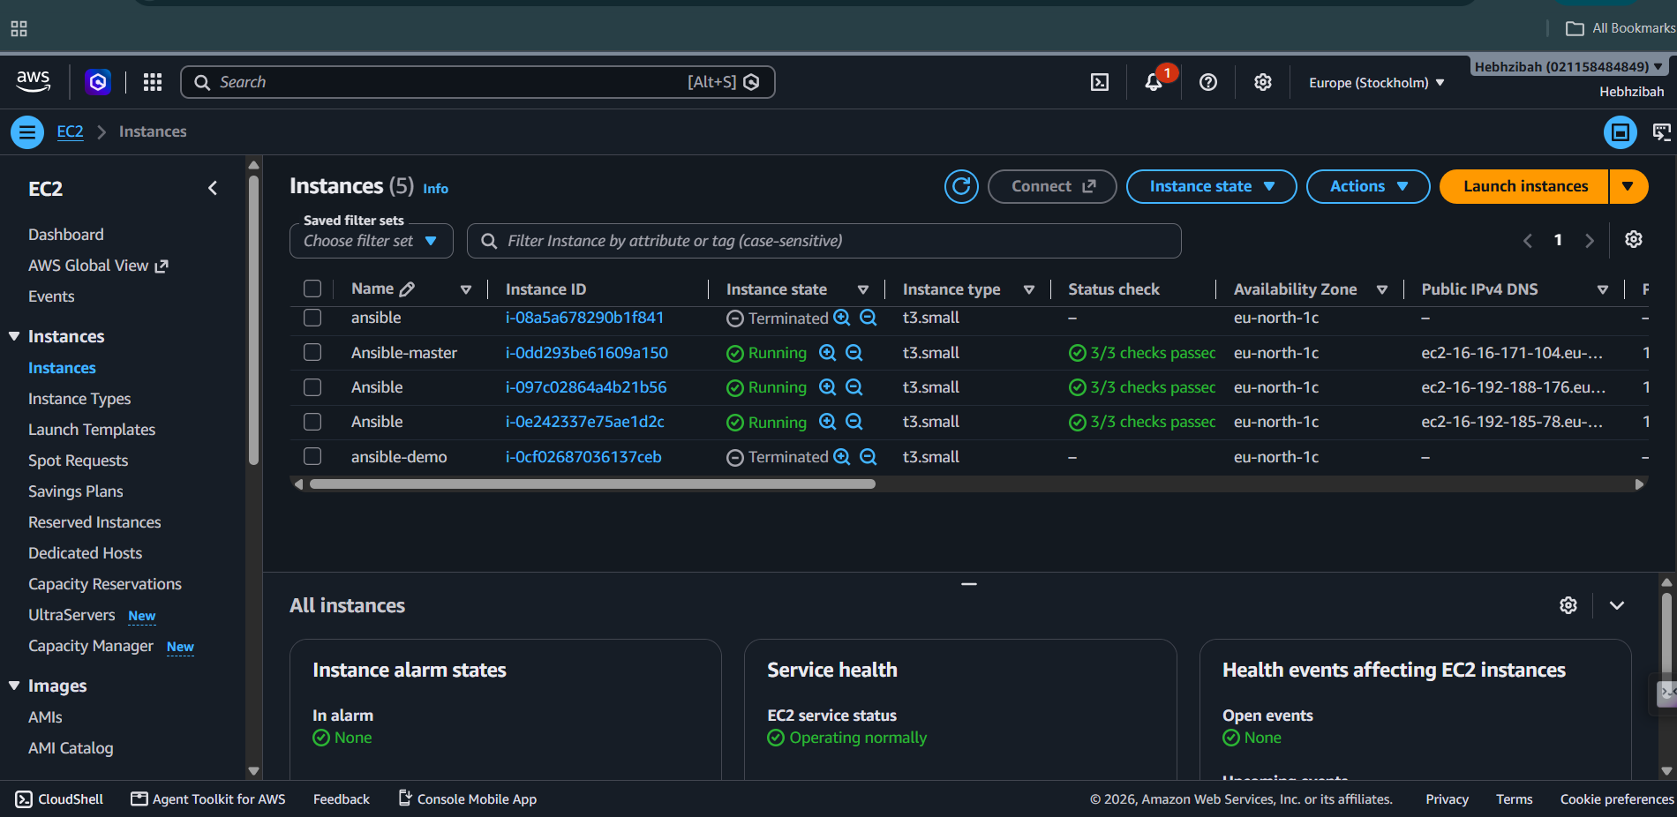
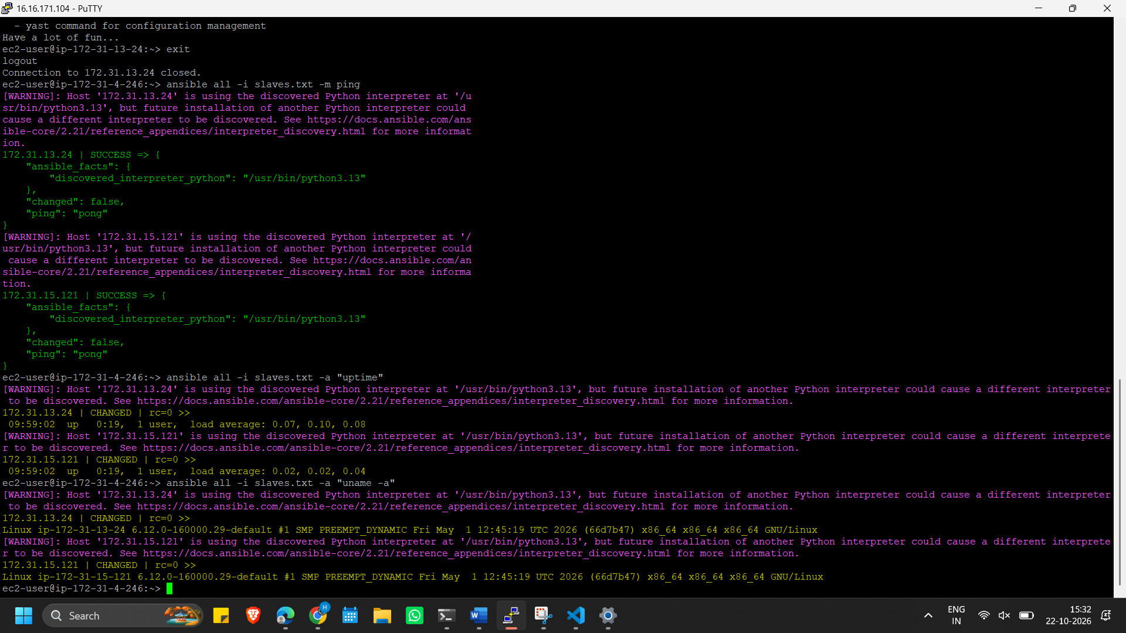

"password": "NOT_LOGGING_PASSWORD" is a security measure, not an error.
